



**Case Study Report**

Data Analytics with Power BI

# AN ANALYSIS OF UNEMPLOYEMENT IN REPUBLIC OF INDIA

# USING POWER BI

**GOVERNMENT ARTS AND SCIENCE COLLEGE**

**VEDARANYAM**

|  |  |
| --- | --- |
| **NM ID** | **NAME** |
| C789E6C8692C8C193E540BC13C0520BC | **S.ASPARKHAN** |

|  |  |  |
| --- | --- | --- |
| **Sr. No.** | **Table of Contents** | **Page No.** |
| 1 | Chapter 1: Introduction | 2 |
| 2 | Chapter 2: Services and Tools Required | 5 |
| 3 | Chapter 3: Project Architecture | 7 |
| 4 | Chapter 4: Modeling and Result | 9 |
| 5 | Conclusion | 18 |
| 6 | Future Scope | 19 |
| 7 | References | 20 |
| 8 | Links | 21 |

# ABSTRACT

Unemployment is a persistent problem in India, with significant social and economic consequences. This paper provides an overview of the current state of unemployment in India, including the latest unemployment rate and the factors contributing to this issue. The paper also examines the various measures that the Indian government has taken to address unemployment, such as skill development programs and the promotion of entrepreneurship and foreign investment. Despite these efforts, the challenge of creating adequate job opportunities for the growing population of India remains significant. This paper highlights the need for continued efforts to address unemployment in India and suggests potential solutions for improving the situation.

**Keywords**: - Unemployment, Difficulties, States, Machine Learning (ML), India.

# INTRODUCTION

Unemployment in India refers to the situation where a significant portion of the population who are willing and able to work are without a job. It is a persistent problem that has various social and economic consequences, including poverty, crime, and inequality.

According to the latest available data from the National Statistical Office (NSO), the unemployment rate in India was 6.1% in 2018-2019. However, this figure does not account for underemployment or people who are working in jobs that are not commensurate with their skills and qualifications.

The factors contributing to unemployment in India are complex and multifaceted. One of the primary reasons is the lack of sufficient job opportunities in the country. The Indian economy has not been able to create enough jobs to absorb the growing workforce. As per a report by the International Labour Organization (ILO), India needs to create approximately 90 million non-farm jobs by 2030 to keep up with the growing workforce.

Another contributing factor is the low levels of education and skill development among the Indian population. Many individuals lack the necessary skills and qualifications to compete for the available jobs, which makes it difficult for them to find employment. The lack of proper education and skill development opportunities further perpetuate the cycle of poverty and unemployment.

Furthermore, there is a mismatch between the skills required by employers and those possessed by job seekers. Many industries in India are looking for highly skilled individuals, but the education and training systems in the country have not been able to keep up with the changing job market. This results in a situation where there are plenty of job openings, but not enough people with the required skills to fill them.

The impact of automation and technology on the job market is also a contributing factor to unemployment in India. Automation and technology have made many jobs redundant, and the individuals who were previously employed in those positions are now struggling to find work.

The Indian government has taken several measures to address the issue of unemployment. The government has launched several skill development programs to equip individuals with the necessary skills and qualifications to compete in the job market. The government is also promoting entrepreneurship and self-employment to create more job opportunities. Additionally, the government is encouraging foreign investment in the country to create more jobs and spur economic growth.

In conclusion, unemployment is a significant challenge facing India, with various complex factors contributing to the issue. Addressing the challenge of unemployment is crucial for building a more prosperous and equitable society in India.

Here are some key factors that have contributed to unemployment in India:

1. Lack of sufficient job opportunities
2. Low levels of education and skill development
3. Mismatch between the skills required by employers and those possessed by job seekers
4. Impact of automation and technology on the job market
5. Slow economic growth
6. Poor infrastructure and inadequate support for small and medium-sized enterprises
7. Gender discrimination and unequal access to opportunities
8. Limited availability of formal sector jobs in rural areas
9. Seasonal and cyclical nature of employment in certain industries
10. Inadequate labour laws and regulations.

# TYPES

There are several types of unemployment that exist in India. Here are some of the most common types:

**Structural Unemployment**: This type of unemployment occurs due to a mismatch between the skills that workers possess and the skills that employers require. It is often caused by changes in the structure of the economy or advances in technology that render certain skills or occupations obsolete.

**Frictional Unemployment:** This type of unemployment occurs due to the time it takes for workers to find new jobs. It is a temporary form of unemployment that is often seen as a natural part of the job search process.

**Cyclical Unemployment**: This type of unemployment occurs due to changes in the business cycle. It is often caused by recessions or other economic downturns that result in a decline in demand for goods and services, leading to job losses.

**Seasonal Unemployment:** This type of unemployment occurs due to seasonal changes in demand for labour. It is common in industries such as agriculture, tourism, and construction, where demand for labour varies throughout the year.

**Hidden Unemployment:** This type of unemployment occurs when individuals who are willing and able to work are not actively seeking employment or are not included in official unemployment statistics. This can happen due to factors such as a lack of job opportunities, family responsibilities, or social barriers.

**Underemployment:** This type of unemployment occurs when individuals are working in jobs that do not fully utilize their skills or qualifications. They may be working part-time when they would prefer full-time employment, or they may be working in low-paying jobs despite having higher levels of education or experience.

It is important to note that these types of unemployment are not mutually exclusive, and individuals may experience more than one type of unemployment over their lifetime. Additionally, the extent and impact of each type of unemployment can vary depending on various factors such as geographic location, education levels, and economic conditions.

# OBJECTIVES

The objective of this research paper is to analyse the data on unemployment in order to gain a deeper understanding of the extent and nature of unemployment in India. By examining various sources of data and employing statistical analysis, this paper aims to provide insights into the factors contributing to unemployment, the types of unemployment prevalent in the country, and the socio-economic consequences of unemployment. Through this analysis, we hope to contribute to a better understanding of this critical issue and inform policies and interventions aimed at reducing unemployment and promoting inclusive economic growth in India.

# METHODOLOGIES

In this research paper, we are utilizing advanced analytical techniques, including **Machine Learning** algorithms, to analyze the data on unemployment in India. By employing these methods, we aim to identify patterns, trends, and relationships in the data that may not be apparent through traditional statistical analysis. Through this approach, we hope to gain a more nuanced and comprehensive understanding of the complexities of unemployment in India, which can inform the development of more effective policies and interventions to address this critical issue.

# PHASES OF ANALYSIS

This research paper is focused on analysing the impact of the COVID-19 pandemic and associated lockdowns on unemployment in India. To do so, we are considering two distinct phases: the period before the lockdowns were implemented, and the period after. By comparing and contrasting the trends and patterns in unemployment data across these two phases, we aim to identify the specific impacts of the pandemic and lockdowns on the labour market in India. Through this analysis, we hope to provide insights into the immediate and long-term consequences of the pandemic on employment in India, and inform policy interventions aimed at mitigating the impacts of this crisis on the country's workforce.

**SERVICE AND TOOLS REQUIRED**

**Table 1. Unemployment rate of India July, 2019- June 2020**

|  |  |  |  |
| --- | --- | --- | --- |
| **Month** | **Unemployment Rate (%)** | | |
|  | India | Urban | Rural |
| Jul-20 | 7.43 | 9.15 | 6.66 |
| Jun-20 | 10.99 | 12.02 | 10.52 |
| May-20 | 23.48 | 25.79 | 22.48 |
| Apr-20 | 23.52 | 24.95 | 22.89 |
| Mar-20 | 8.75 | 9.41 | 8.44 |
| Feb-20 | 7.76 | 8.65 | 7.34 |
| Jan-20 | 7.22 | 9.7 | 6.06 |
| Dec-19 | 7.6 | 9.02 | 6.93 |
| Nov-19 | 7.23 | 8.88 | 6.45 |
| Oct-19 | 8.1 | 8.27 | 8.02 |
| Sep-19 | 7.14 | 9.58 | 5.99 |
| Aug-19 | 8.19 | 9.71 | 7.48 |

*Source: Centre for Monitoring Indian Economy Pvt. Ltd.*

**Figure 1. Unemployment Rate of India July, 2019- June 2020**



Unemployment rate of India July, 2019- June 2020

30

25

INDIA

20

Urban

5

*Source: Centre for Monitoring Indian Economy Pvt. Ltd.*

**Figure 2. Moving Average showing Unemployment rate of India**



Unemployment Rate - 30 day moving average (%)

12

10

8

6

4

India

Urban

Rural

*Source: Centre for Monitoring Indian Economy Pvt. Ltd.*

**Table 2. Unemployment Rate - 30 day moving average (%)**

|  |  |  |  |
| --- | --- | --- | --- |
| Date | India | Urban | Rural |
| 9-Aug-20 | 7.86 | 9.72 | 6.99 |
| 8-Aug-20 | 7.65 | 9.67 | 6.72 |
| 7-Aug-20 | 7.64 | 9.74 | 6.67 |
| 6-Aug-20 | 7.67 | 9.69 | 6.73 |
| 5-Aug-20 | 7.63 | 9.64 | 6.71 |
| 4-Aug-20 | 7.73 | 9.74 | 6.82 |
| 3-Aug-20 | 7.75 | 9.7 | 6.86 |
| 2-Aug-20 | 7.72 | 9.74 | 6.8 |
| 1-Aug-20 | 7.64 | 9.7 | 6.71 |
| 31-Jul-20 | 7.59 | 9.76 | 6.6 |
| 30-Jul-20 | 7.54 | 9.7 | 6.55 |
| 29-Jul-20 | 7.57 | 9.79 | 6.56 |
| 28-Jul-20 | 7.69 | 9.85 | 6.72 |
| 27-Jul-20 | 7.78 | 10 | 6.77 |
| 26-Jul-20 | 7.97 | 10.39 | 6.87 |
| 25-Jul-20 | 8.02 | 10.38 | 6.96 |
| 24-Jul-20 | 7.79 | 10.4 | 6.6 |
| 23-Jul-20 | 7.88 | 10.47 | 6.7 |
| 22-Jul-20 | 7.84 | 10.53 | 6.62 |
| 21-Jul-20 | 7.9 | 10.62 | 6.66 |
| 20-Jul-20 | 7.94 | 10.69 | 6.68 |
| 19-Jul-20 | 7.95 | 10.81 | 6.64 |
| 18-Jul-20 | 8.09 | 10.79 | 6.83 |
| 17-Jul-20 | 8.29 | 10.76 | 7.14 |

*Source: Centre for Monitoring Indian Economy Pvt. Ltd.*

* 1. **PHASE 2: DURING LOCKDOWN**

Consider the following figures:

**Table 3. Unemployment Rate of Indian states & UT, between lockdown phases**

|  |  |  |  |  |  |
| --- | --- | --- | --- | --- | --- |
| States | Mar-20 | Apr-20 | May-20 | Jun-20 | Jul-20 |
| Andhra Pradesh | 5.8 | 20.5 | 17.5 | 2.1 | 8.3 |
| Assam | 4.8 | 11.1 | 9.6 | 0.6 | 3.2 |
| Bihar | 15.4 | 46.6 | 46.2 | 19.5 | 12.2 |
| Chhattisgarh | 7.5 | 3.4 | 11.3 | 14.4 | 9 |
| Delhi | 17 | 16.7 | 44.9 | 18.2 | 20.3 |
| Goa | 5.2 | 13.3 | 21.2 | 10.1 | 17.1 |
| Gujarat | 6.7 | 18.7 | 13.6 | 2.8 | 1.9 |
| Haryana | 25.1 | 43.2 | 35.7 | 33.6 | 24.5 |
| Himachal Pradesh | 18.8 | 2.2 | 28.2 | 2.1 | 18.6 |
| Jammu & Kashmir | 15.5 | NA | 5.2 | 17.9 | 11.2 |
| Jharkhand | 8.2 | 47.1 | 59.2 | 21 | 8.8 |
| Karnataka | 3.5 | 29.8 | 20.4 | 9.2 | 3.6 |
| Kerala | 9 | 17 | 26.5 | 20.1 | 6.8 |
| Madhya Pradesh | 2.2 | 12.4 | 27.5 | 8.2 | 3.6 |
| Maharashtra | 5.8 | 20.9 | 16.5 | 9.7 | 4.4 |
| Meghalaya | 1.6 | 10 | 5.9 | 1.1 | 2.1 |
| Odisha | 13.1 | 23.8 | 9.6 | 4.2 | 1.9 |
| Pondicherry | 1.2 | 75.8 | 58.2 | 4.2 | 21.1 |
| Punjab | 10.3 | 2.9 | 33.6 | 16.8 | 10.4 |
| Rajasthan | 11.9 | 17.7 | 14.1 | 13.7 | 15.2 |
| Sikkim | 23.6 | 2.3 | 24.5 | 4.7 | 4.5 |
| Tamil Nadu | 6.4 | 49.8 | 33 | 13.5 | 8.1 |
| Telangana | 5.8 | 6.2 | 34.8 | 15.5 | 9.1 |
| Tripura | 29.9 | 41.2 | 15.3 | 21.3 | 16.4 |
| Uttar Pradesh | 10.1 | 21.5 | 20.8 | 9.6 | 5.5 |
| Uttarakhand | 19.9 | 6.5 | 8 | 8.7 | 12.4 |
| West Bengal | 6.9 | 17.4 | 17.4 | 6.5 | 6.8 |
| **India** | **8.8** | **23.5** | **23.5** | **11** | **7.4** |

*Source: Centre for Monitoring Indian Economy Pvt. Ltd.*

**Figure 3. Unemployment Rate of Indian states & UT**

*Source: Centre for Monitoring Indian Economy Pvt. Ltd.*

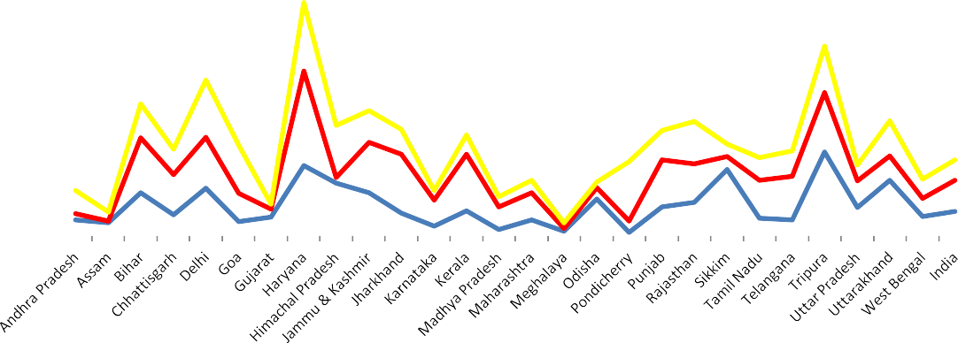

160

140

120

20-May

100

20-Apr

20-Jul 20-Jun

20

# DATA ANALYSIS

In this research paper, we are **utilizing machine learning algorithms** to analyze the data on unemployment in India. By employing these advanced analytical techniques, we aim to gain a deeper understanding of the complex relationships and interactions between various factors contributing to unemployment, including education levels, gender, age, and industry sectors. Through this approach, we hope to develop more **accurate predictive models** for forecasting future trends in unemployment, and identify key variables and factors that policymakers can target to reduce unemployment and promote more inclusive economic growth in India. Ultimately, this research aims to contribute to the development of evidence-based policies and interventions to address the critical issue of unemployment in India.

In this research paper, we are utilizing **a sample of the population data** on unemployment in India. The sample is derived from a variety of sources, including official statistics from government agencies, surveys of households and businesses, and other publicly available data. The sample has been carefully selected to ensure representativeness and accuracy, and has undergone rigorous quality control measures to ensure data integrity. Through this approach, we aim to draw insights and conclusions about the broader population of unemployed individuals in India, while also acknowledging the limitations of working with a sample rather than a complete population dataset. By **utilizing statistical techniques** to account for sampling bias and other potential sources of error, we aim to develop **reliable and robust findings** that can inform policies and interventions aimed at reducing unemployment and promoting more inclusive economic growth in India.

We will be analysing a sample data from this csv: **Unemployment_Rate_upto_11_2020.csv**

Link: <https://www.kaggle.com/datasets/gokulrajkmv/unemployment-in-india>

**Context**

The story behind this dataset is how lock-down affects employment opportunities and how the unemployment rate increases during the Covid-19.

**Content**

This dataset contains the unemployment rate of all the states in India Region = states in India

Date = date which the unemployment rate observed

Frequency = measuring frequency (Monthly)

Estimated Unemployment Rate (%) = percentage of people unemployed in each state of India Estimated Employed = percentage of people employed

Estimated Labour Participation Rate (%) = labour force participation rate by dividing the number of people actively participating in the labour force by the total number of people eligible to participate in the labour force

**Describing the data:**

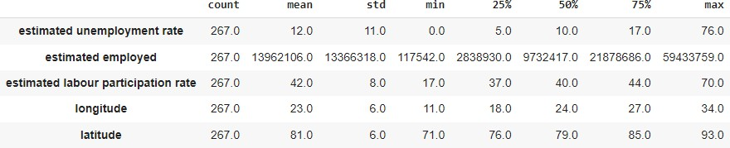

Average unemployment rate in India was 12% in 2020

**Labour Participation Rate in Unemployment: Before Lockdown:**

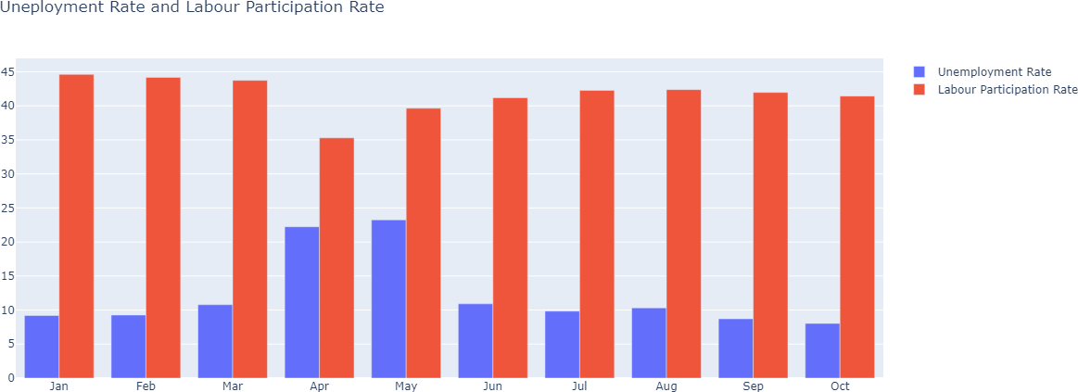

**During Lockdown:**

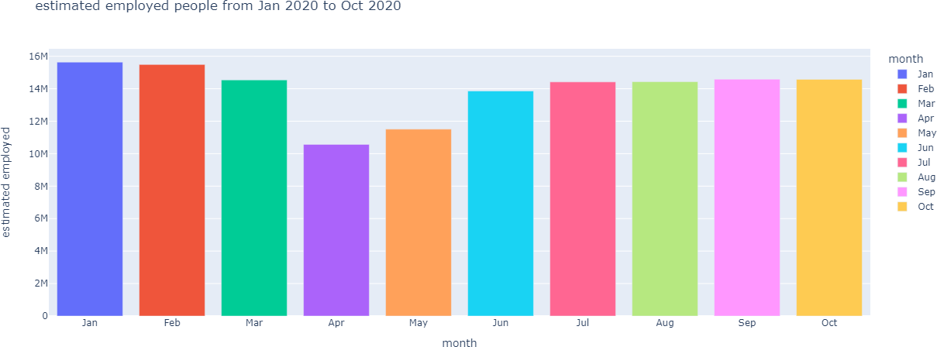

**State-wise Analysis: Unemployment Rate:**

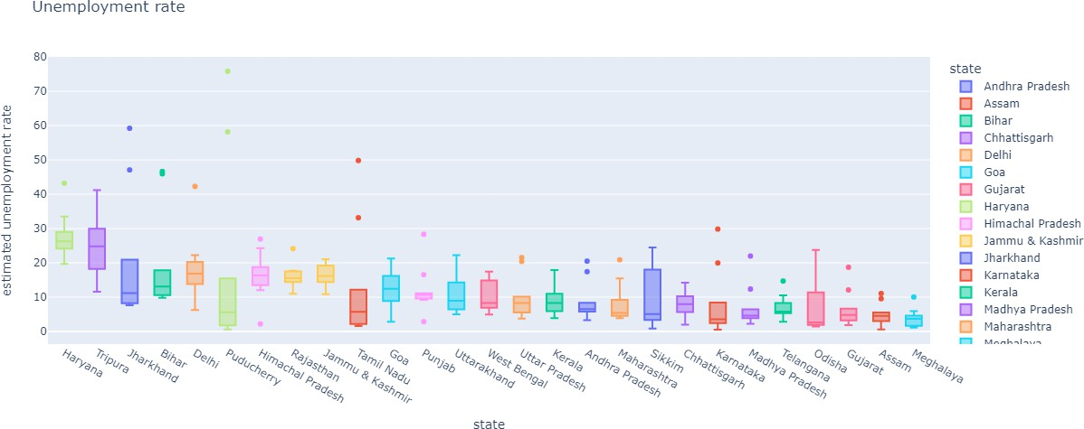

**Average Unemployment Rate:**

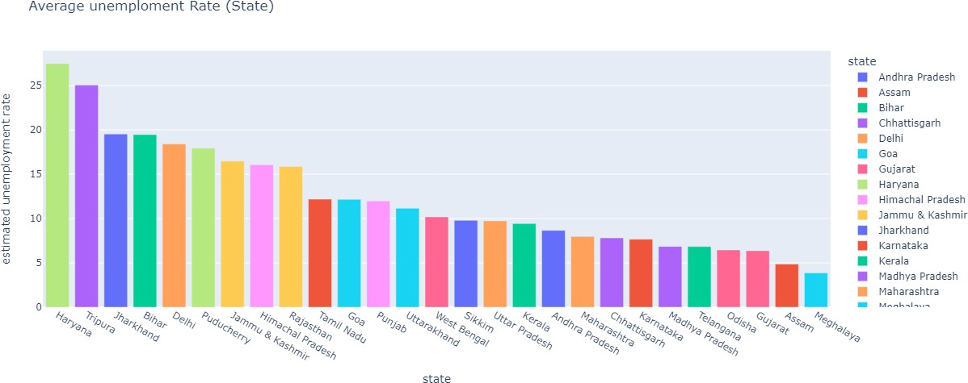

**During Lockdown Phase:**

**January – 2020:**

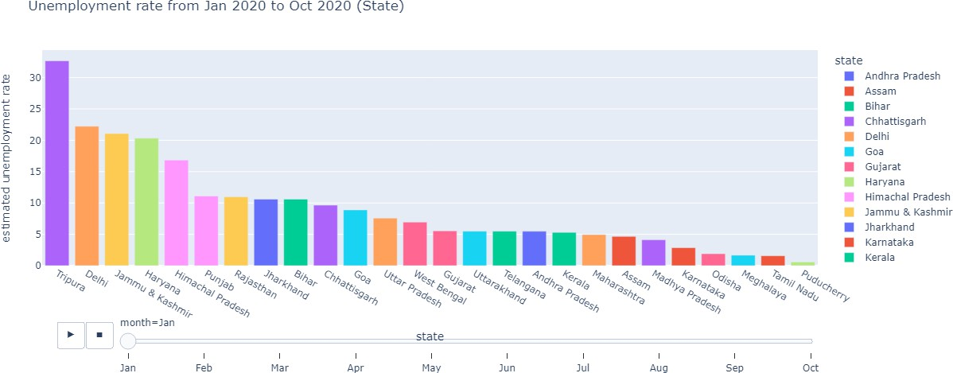

**October – 2020:**

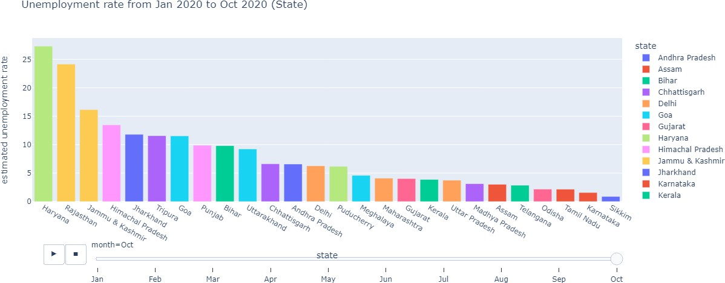

**ScatterPlot:**

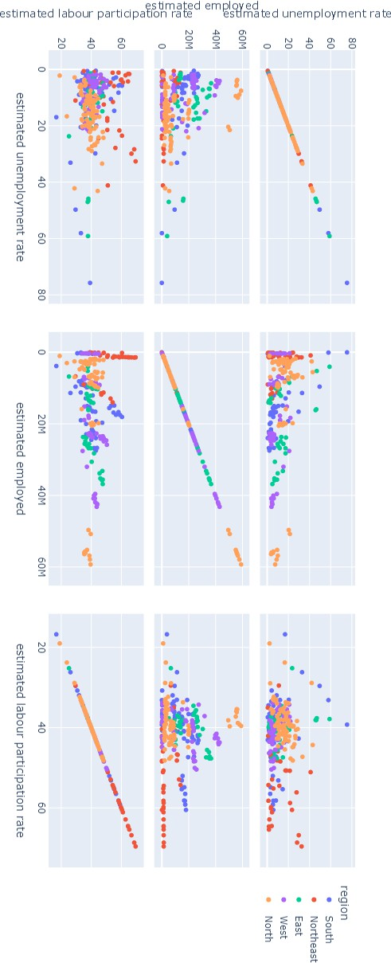

**Region-Wise Analysis:**

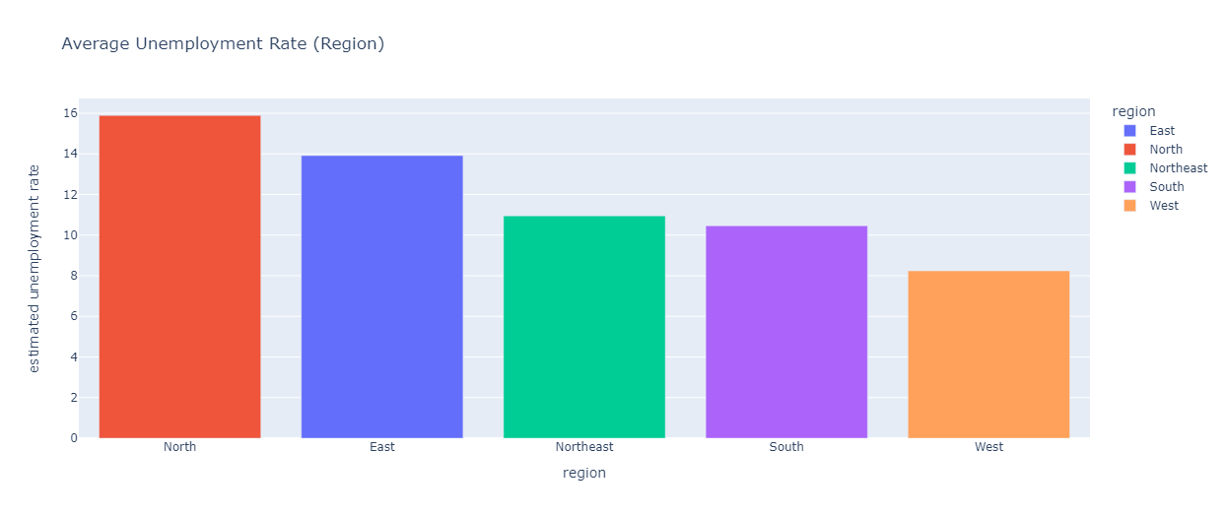

**January – 2020:**

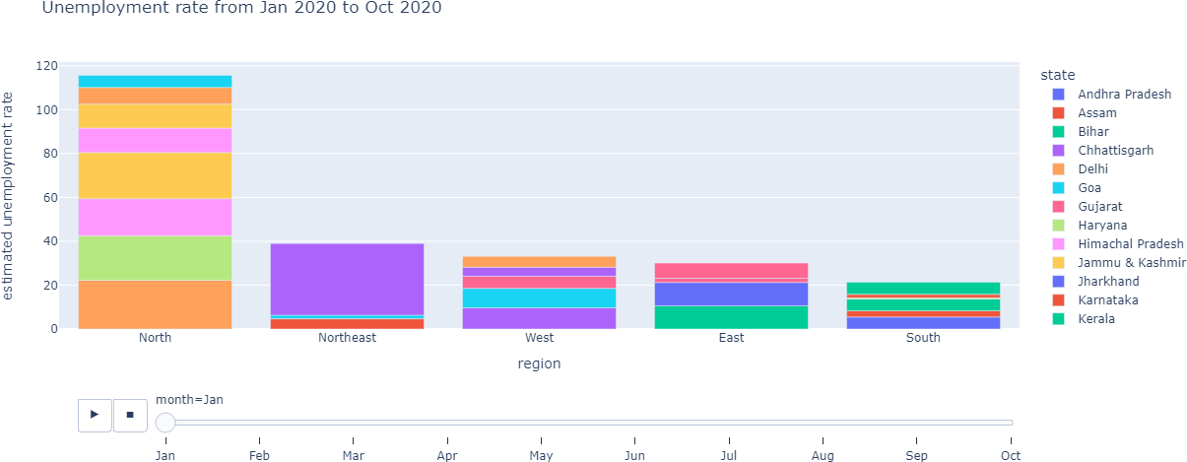

**October – 2020:**

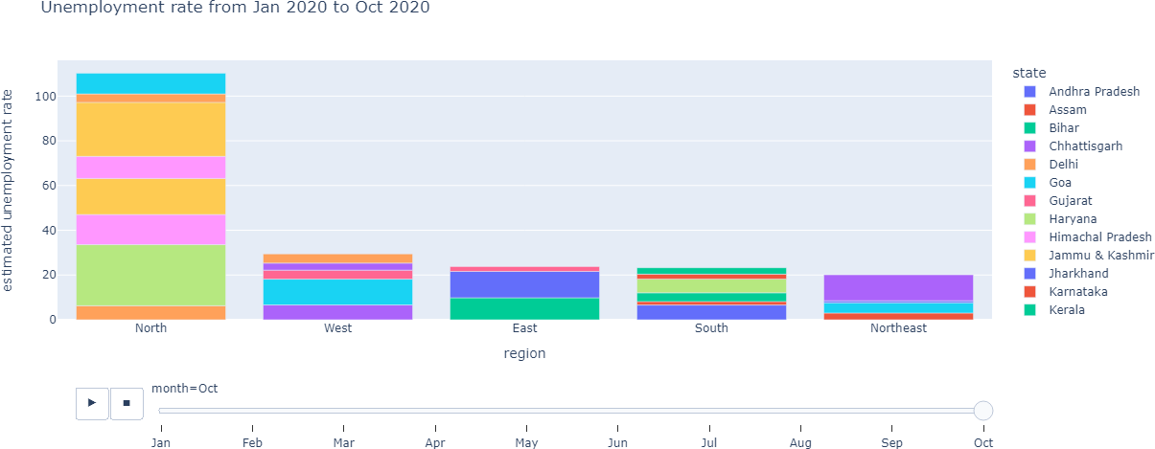

**Mean Unemployment Before & During Lockdown:**

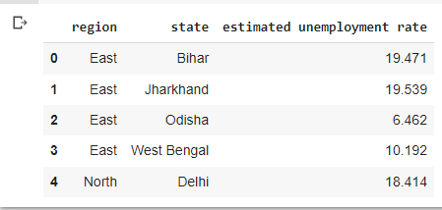

**Sunburst Plot for Unemployment Diagram in every region within state:**

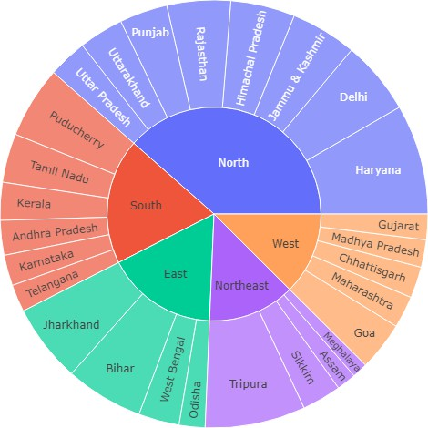

**Aftermath Lockdown Unemployment Analysis:**

**Percentage Change in Unemployment:**

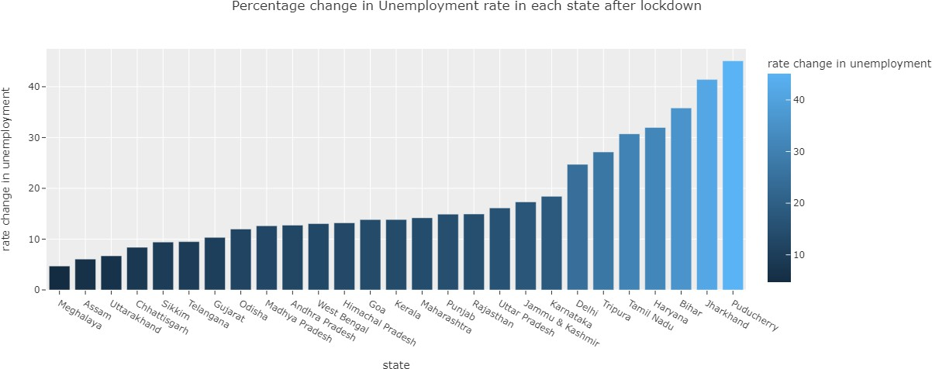

# CONCLUSION

In conclusion, this research paper has utilized advanced analytical techniques, including machine learning algorithms, to analyze the data on unemployment in India.

By considering two distinct phases - before and after the COVID-19 pandemic and associated lockdowns - we have gained insights into the impacts of the crisis on employment in India, and identified key variables and factors contributing to unemployment.

Reducing unemployment in India requires a multi-faceted approach that addresses the various factors contributing to the problem.

Some key strategies that can be employed include increasing investment in education and skills development programs to enhance employability, promoting entrepreneurship and innovation to create new job opportunities, and targeting industry sectors with high growth potential.

It is also important to address structural barriers such as discrimination, gender inequality, and lack of access to basic infrastructure and services.

By implementing these strategies and interventions, we can work towards reducing unemployment in India and promoting a more inclusive and equitable society.

# VII. LIMITATIONS

The data used here is just a sample, with this we cannot hold enough strength for full functionally corrected analysis.

This is just a sample of whole millions of data within populations.

* Access to advanced databases is restricted owing to lack of subscription;
* Survey data is not the most dependable source for undertaking statistical analysis;
* Recurrent inaccuracies in reported data due to nulls and blanks;
* Inadequate equipment for processing massive amounts of data
* Inadequate availability of all variables in the databases

# IX. TOOLS USED

1. Python
2. Jupyter Notebook
3. Google Collab
4. Kaggle
5. UCI Datasets Repository
6. Various Research Papers

# X. REFERENCES

[1]. <https://www.kaggle.com/datasets/gokulrajkmv/unemployment-in-india>

[2][.https://drive.google.com/drive/folders/1TUKVXnaZuLRamIm25bdFUiwnGARx1yW5?u](https://drive.google.com/drive/folders/1TUKVXnaZuLRamIm25bdFUiwnGARx1yW5?usp=share_link) [sp=share_link](https://drive.google.com/drive/folders/1TUKVXnaZuLRamIm25bdFUiwnGARx1yW5?usp=share_link)

[3][.(PDF) A STUDY ON IMPACT OF COVID-19 PANDEMIC ON UNEMPLOYMENT IN INDIA](https://www.researchgate.net/publication/348555450_A_STUDY_ON_IMPACT_OF_COVID-19_PANDEMIC_ON_UNEMPLOYMENT_IN_INDIA)

[(researchgate.net)](https://www.researchgate.net/publication/348555450_A_STUDY_ON_IMPACT_OF_COVID-19_PANDEMIC_ON_UNEMPLOYMENT_IN_INDIA)

[4][.(PDF) "Research report on Indian Unemployment scenario and its analysis of causes , trends and](https://www.researchgate.net/publication/347934467_Research_report_on_Indian_Unemployment_scenario_and_its_analysis_of_causes_trends_and_solutions_A_PROJECT_STUDY_SUBMITTED_IN_PARTIAL_FULFILLMENT_FOR_THE_REQUIREMENT_OF_THE_TWO_YEAR_FULL-TIME_POST-GRAD) [solutions" A PROJECT STUDY SUBMITTED IN PARTIAL FULFILLMENT FOR THE REQUIREMENT OF THE](https://www.researchgate.net/publication/347934467_Research_report_on_Indian_Unemployment_scenario_and_its_analysis_of_causes_trends_and_solutions_A_PROJECT_STUDY_SUBMITTED_IN_PARTIAL_FULFILLMENT_FOR_THE_REQUIREMENT_OF_THE_TWO_YEAR_FULL-TIME_POST-GRAD) [TWO YEAR (FULL-TIME) POST-GRADUATE DIPLOMA IN MANAGEMENT (2018 -20) BY UNDER THE](https://www.researchgate.net/publication/347934467_Research_report_on_Indian_Unemployment_scenario_and_its_analysis_of_causes_trends_and_solutions_A_PROJECT_STUDY_SUBMITTED_IN_PARTIAL_FULFILLMENT_FOR_THE_REQUIREMENT_OF_THE_TWO_YEAR_FULL-TIME_POST-GRAD)

[GUIDANCE OF (researchgate.net)](https://www.researchgate.net/publication/347934467_Research_report_on_Indian_Unemployment_scenario_and_its_analysis_of_causes_trends_and_solutions_A_PROJECT_STUDY_SUBMITTED_IN_PARTIAL_FULFILLMENT_FOR_THE_REQUIREMENT_OF_THE_TWO_YEAR_FULL-TIME_POST-GRAD)

[5]. [A Comparative Study of Unemployment in India and USA Dr. Niyati Chaudhary](https://www.ijsrp.org/research-paper-1220/ijsrp-p10844.pdf#%3A~%3Atext%3DAbstract-%20Unemployment%20is%20a%20major%20problem%20in%20India.%2Care%20needed%20to%20get%20rid%20of%20this%20problem) [6]. [UNEMPLOYMENT IN INDIA by Dr. Janak Singh Kushwah](https://ijirt.org/Article?manuscript=153639)

[7]. [Analysis of the Unemployment in India: Causes and Solutions by Avinash Raj David](https://www.jetir.org/view?paper=JETIREV06021)

[8]. Research report on Indian Unemployment scenario and its analysis of causes , trends and solutions

[9]. [UNEMPLOYMENT IN INDIA by SUSHMITA BISWAS](https://nationalconference.org.in/up_proc/pdf/23-145352902225-27.pdf)

[10]. [A study of unemployment in India, causes and implication Anala Upadhya and Sruthy](https://www.allresearchjournal.com/archives/2017/vol3issue4/PartK/3-3-141-348.pdf) [Unnikrishnan](https://www.allresearchjournal.com/archives/2017/vol3issue4/PartK/3-3-141-348.pdf)

[11]. [Indian Economy - Unemployment in India](https://www.drishtiias.com/to-the-points/paper3/unemployment-in-india)

[12]. [Youth Employment and Unemployment in India by S. Mahendra Dev and M.](http://igidr.ac.in/pdf/publication/WP-2011-009.pdf)

[Venkatanarayana](http://igidr.ac.in/pdf/publication/WP-2011-009.pdf)

[13]. [Causes of Youth Unemployment: Emerging Issue in Indian Economy by Rubee Singh,](https://papers.ssrn.com/sol3/papers.cfm?abstract_id=3351740)

[Archana Raj](https://papers.ssrn.com/sol3/papers.cfm?abstract_id=3351740)

[14]. [A STUDY ON IMPACT OF COVID-19 PANDEMIC ON UNEMPLOYMENT IN](https://www.researchgate.net/publication/348555450_A_STUDY_ON_IMPACT_OF_COVID-19_PANDEMIC_ON_UNEMPLOYMENT_IN_INDIA) [INDIA](https://www.researchgate.net/publication/348555450_A_STUDY_ON_IMPACT_OF_COVID-19_PANDEMIC_ON_UNEMPLOYMENT_IN_INDIA)

[15]. [A STUDY ON THE CAUSES AND IMPACT OF UNEMPLOYMENT IN INDIA by](https://digitalcommons.du.edu/cgi/viewcontent.cgi?article=1219&context=irbe) [Ms. SHRUTI NAIR](https://digitalcommons.du.edu/cgi/viewcontent.cgi?article=1219&context=irbe)

[16]. [Rising Unemployment in India : A Statewise Analysis from 1993–94 to 2017–18 |](https://www.epw.in/journal/2019/50/commentary/rising-unemployment-india.html) [Economic and Political Weekly (epw.in)](https://www.epw.in/journal/2019/50/commentary/rising-unemployment-india.html)

[17]. [Underemployment in India: Measurement and Analysis By Subrata Mukherjee,](http://idsk.edu.in/wp-content/uploads/2018/03/OP-58.pdf)

[Dipankor Coondoo, Indrani Chakraborty](http://idsk.edu.in/wp-content/uploads/2018/03/OP-58.pdf)

[18]. [A Critical Review on Unemployment and Economic Growth, Engineering Education](https://www.irjet.net/archives/V3/i5/IRJET-V3I5284.pdf) [and Civil Engineers Career up Graduation in India by A.Rajesh kumar1, Dr.k.Murali2](https://www.irjet.net/archives/V3/i5/IRJET-V3I5284.pdf)

[19]. [Unemployment in India – Types, Causes, Impact and Steps to Overcome](https://data-flair.training/blogs/unemployment-in-india/)

**REFERENCE**

**LINK:**